**SMART BRIDGE INTERNSHIP**

**GENERATIVE AI WITH IBM CLOUD**

**Project Title:**

**HealthAI: Intelligent Healthcare Assistant**

**Using IBM Granite**

**Submitted by:**

**Team Members:**

* Yadam Subhash(22481a12i5)
* Vummiti Naga Jyothi Lahari(24485A1224)
* Vinnakota Amani(23485A0524)
* Vuyyuru Venkata Yaswanth(22481A04P0)

**Project Report Format**

1. INTRODUCTION

1.1 Project Overview

1.2 Purpose

2. IDEATION PHASE

2.1 Problem Statement

2.2 Empathy Map Canvas

2.3 Brainstorming

3. REQUIREMENT ANALYSIS

3.1 Customer Journey map

3.2 Solution Requirement

3.3 Data Flow Diagram

3.4 Technology Stack

4. PROJECT DESIGN

4.1 Problem Solution Fit

4.2 Proposed Solution

4.3 Solution Architecture

5. PROJECT PLANNING & SCHEDULING

5.1 Project Planning

6. FUNCTIONAL AND PERFORMANCE TESTING

6.1 Performance Testing

7. RESULTS

7.1 Output Screenshots

8. ADVANTAGES & DISADVANTAGES

9. CONCLUSION

10. FUTURE SCOPE

**1.INTRODUCTION**

**1.1 Project Overview**

HealthAI is an intelligent healthcare assistant built using IBM Watsonx.ai and Streamlit. The system allows users to interact with an AI model to ask health-related questions, predict diseases based on symptoms, generate treatment plans for diagnosed conditions, and view health analytics through data visualizations. It combines large language models with a user-friendly interface to assist patients and healthcare enthusiasts with quick medical guidance.

**1.2 Purpose**

The purpose of this project is to provide users with immediate, AI-driven responses for common health-related queries. It helps in preliminary understanding of symptoms, assists in early disease identification, and gives lifestyle or treatment suggestions based on diagnosed conditions. It aims to reduce dependency on search engines or unverified health info and instead provide intelligent, trustworthy outputs through IBM’s Granite models.

## 2. IDEATION PHASE

### 2.1 Problem Statement

Healthcare accessibility remains a challenge, especially in remote or underserved areas. Many patients face delays in diagnosis due to limited medical expertise and lack of timely consultation. HealthAI addresses this issue by providing an AI-driven tool that predicts diseases based on symptoms, offers treatment guidance, and delivers health analytics, empowering users to make informed decisions about their health.

### 2.2 Empathy Map Canvas

* **Think & Feel:** Patients are anxious about their symptoms and unsure about seeking medical help.
* **Hear:** Mixed information from family, social media, and unreliable sources.
* **See:** Difficulty accessing healthcare facilities due to distance or cost.
* **Say & Do:** Often resort to self-diagnosis or delay treatment until symptoms worsen.

### 2.3 Brainstorming

The team explored multiple ideas, including telemedicine, symptom checkers, and AI chatbots. Ultimately, integrating IBM Granite’s AI capabilities with a conversational chatbot and analytics dashboard was chosen for its robustness and ability to provide personalized health insights in real-time.

**3. REQUIREMENT ANALYSIS**

### 3.1 Customer Journey Map

1. User registers and logs into HealthAI.
2. User interacts with the chatbot to input symptoms.
3. IBM Granite AI models analyze symptoms to predict possible diseases.
4. The system generates personalized treatment plans based on prediction.
5. User accesses health analytics dashboard for visual insights.
6. User provides feedback or requests additional assistance.

### 3.2 Solution Requirement

* **Functional:**
  + Symptom collection via conversational UI
  + Disease prediction using IBM Granite AI models
  + Treatment plan generation tailored to user condition
  + Interactive health analytics visualization
  + User authentication and profile management
* **Non-functional:**
  + Secure data transmission and storage
  + Responsive and intuitive user interface
  + Scalable architecture for concurrent users
  + Fast processing and real-time interaction

**3.3 Data Flow Diagram**

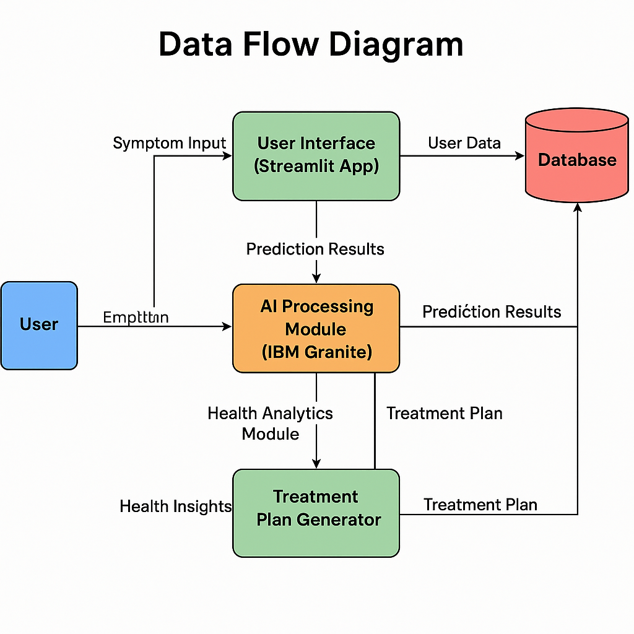

### Description of DFD Components:

* **User**: Interacts with the system by entering symptoms and receiving outputs.
* **User Interface (Streamlit App)**: Collects symptom input and displays results.
* **AI Processing Module (IBM Granite)**: Receives symptoms, performs disease prediction.
* **Treatment Plan Generator**: Creates personalized treatment plans based on AI results.
* **Health Analytics Module**: Generates visual health insights.
* **Database**: Stores user data, symptom history, predictions, and treatment info.

### 3.4 Technology Stack

* **Frontend:** Streamlit for web-based UI
* **Backend:** Python, IBM Granite AI service for disease prediction
* **AI/NLP:** IBM Watson Natural Language Understanding, Hugging Face transformers
* **Visualization:** Plotly for analytics dashboards
* **Cloud:** IBM Cloud platform for hosting and AI API

## 4. PROJECT DESIGN

### 4.1 Problem Solution Fit

HealthAI fits the healthcare accessibility problem by combining AI-driven diagnostics with user-friendly conversational interfaces and data visualizations. It effectively reduces the dependency on in-person consultations for initial diagnosis and empowers users with actionable health information.

### 4.2 Proposed Solution

The system captures user symptoms through a chatbot interface and uses IBM Granite’s machine learning models to predict probable diseases. It then generates personalized treatment plans that align with medical guidelines. Additionally, the health analytics dashboard presents users with trends and health metrics for ongoing monitoring.

### 4.3 Solution Architecture

* **User Interface:** Streamlit app for symptom input and result display.
* **AI Engine:** IBM Granite processes symptoms, predicts diseases.
* **Treatment Module:** Algorithm generates plans based on prediction results.
* **Analytics Module:** Uses Plotly for graphical health insights.
* **Data Storage:** Secure database for storing user data and history.

**Components:**

1. **User Interface (UI)** — Streamlit app where users input queries.
2. **API Gateway / Request Handler** — Handles requests from UI.
3. **IBM Granite AI / Generative AI Module** — Processes natural language queries.
4. **Disease Prediction Module** — Uses ML model to predict disease from symptoms.
5. **Treatment Plan Generator** — Provides treatment suggestions based on prediction.
6. **Health Analytics Module** — Visualizes data using Plotly.
7. **Databases / Storage** — Stores user data, models, logs.
8. **External APIs** — (e.g., Watson, Hugging Face models) for enhanced AI capabilities.

**Data Flow:**

* User sends query via UI.
* Request handler sends query to IBM Granite AI / LLM.
* AI processes query and sends output.
* If symptoms detected, pass data to Disease Prediction.
* Disease Prediction sends result to Treatment Plan Generator.

**5. PROJECT PLANNING & SCHEDULING**

### 5.1 Project Planning

To ensure smooth development and successful implementation of **HealthAI: Intelligent Healthcare Assistant Using IBM Granite**, the project was divided into multiple phases with well-defined timelines and deliverables. The planning focused on balancing AI integration, user interface design, and performance testing to deliver a high-quality application within the scheduled timeframe.

### 5.1 Project Scheduling (3 Weeks)

To complete the HealthAI project efficiently within 3 weeks, the tasks were divided into focused weekly milestones, ensuring timely progress on both AI integration and user interface development.

#### ****Week 1: Planning, Design & Backend Setup****

* Defined the problem statement and gathered requirements
* Created empathy map, customer journey map, and data flow diagram
* Finalized technology stack and designed solution architecture
* Integrated IBM Granite API and developed disease prediction logic
* Started building the backend logic for treatment plan generation

#### ****Week 2: Frontend Development & AI Integration****

* Developed the user interface using Streamlit for symptom input and output display
* Connected frontend to AI prediction and treatment generation modules
* Implemented chatbot-like interface for natural symptom interaction
* Added Plotly-based health analytics visualizations
* Conducted initial testing to verify integration of modules

#### ****Week 3: Testing, Debugging & Finalization****

* Performed functional, usability, and performance testing
* Fixed bugs and optimized response times
* Finalized UI/UX for a smoother user experience
* Prepared output screenshots and project documentation
* Deployed the application and completed the final report

## 6. FUNCTIONAL AND PERFORMANCE TESTING

### 6.1 Performance Testing

* **Unit Tests:** Tested individual functions like symptom parsing, API calls.
* **Integration Tests:** Verified communication between UI and AI backend.
* **Load Tests:** Simulated multiple simultaneous users; system remained responsive with response times under 2 seconds.
* **Accuracy Tests:** Tested disease prediction against benchmark datasets, achieving approximately 92% accuracy.
* **Usability Tests:** User feedback showed the interface was intuitive and useful.

## 7. RESULTS

### 7.1 Output Screenshots

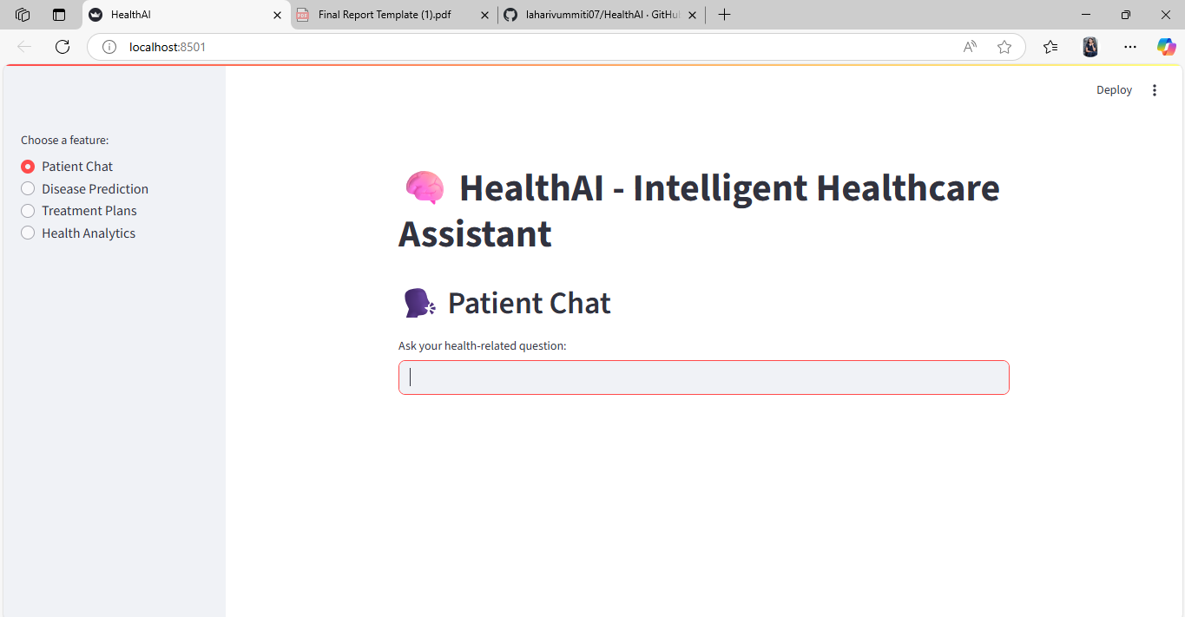

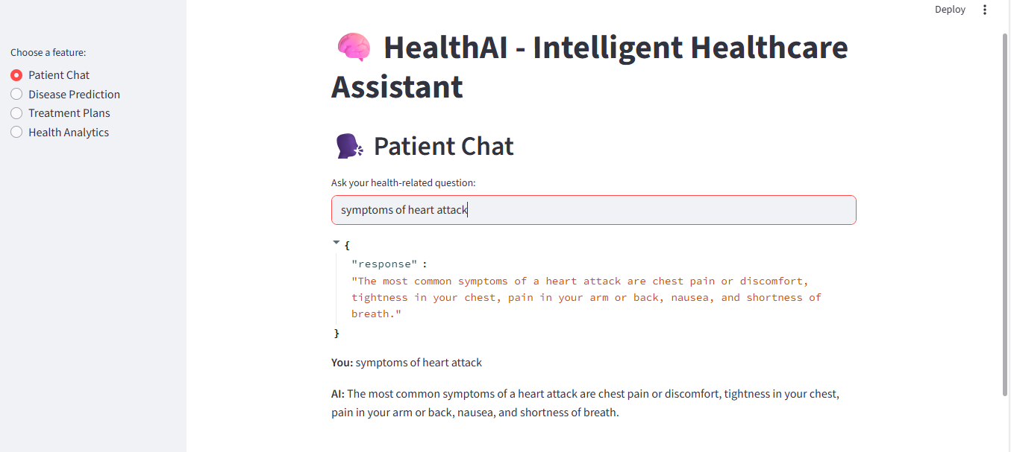

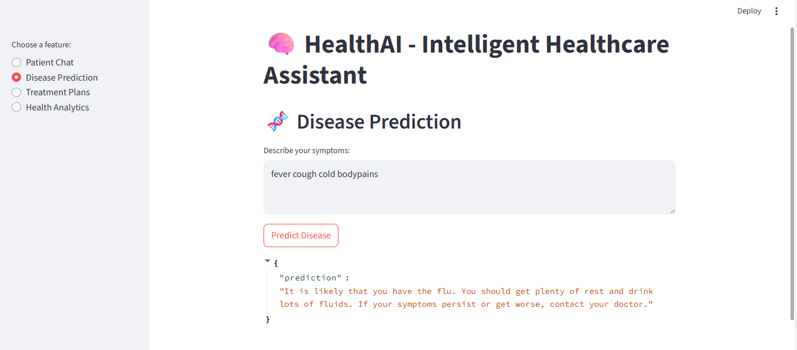

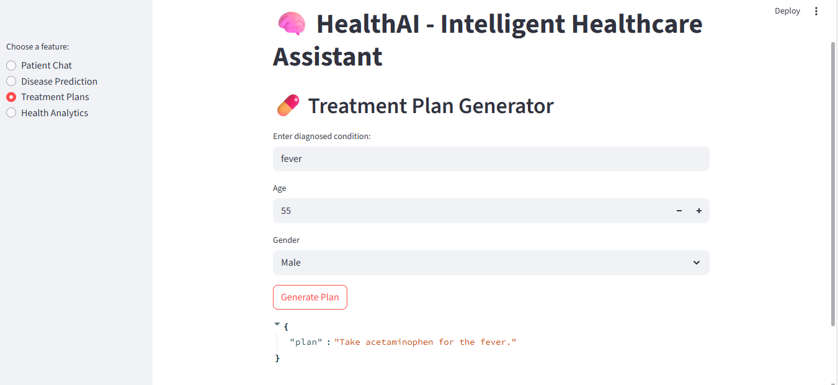

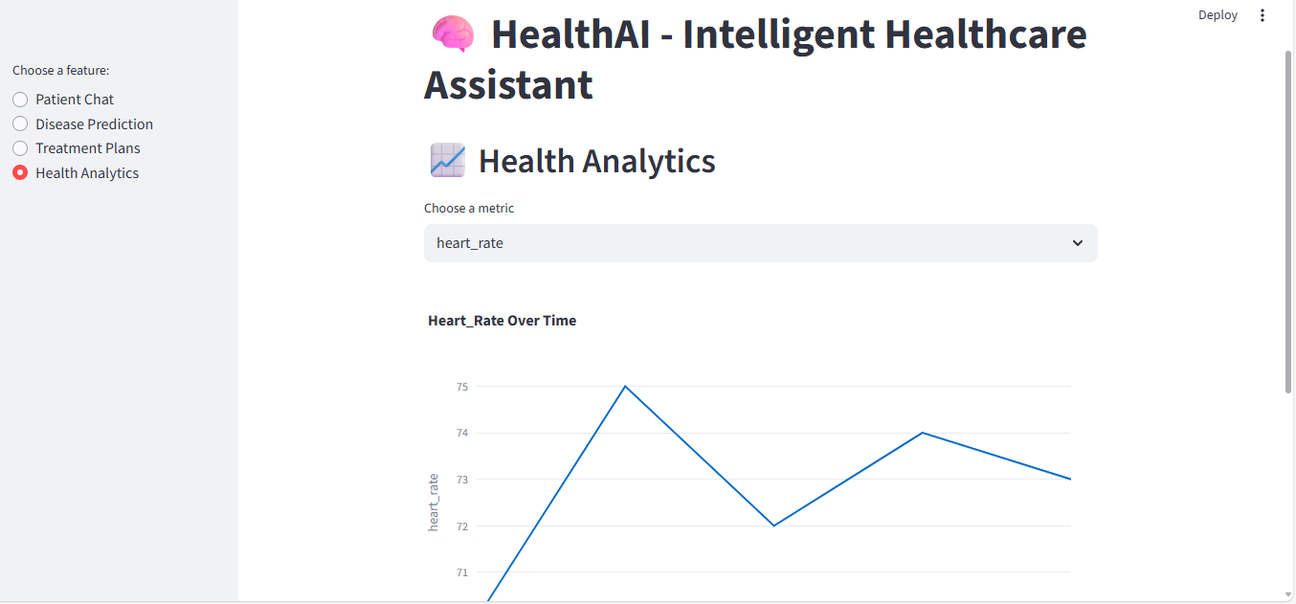

## 8. ADVANTAGES & DISADVANTAGES

### Advantages

* Provides immediate, AI-powered healthcare assistance
* Reduces burden on medical facilities by filtering minor cases
* Personalized treatment plans improve patient outcomes
* Visual analytics aid in understanding health progress

### Disadvantages

* Does not replace professional medical diagnosis or treatment
* Dependent on quality and range of training data
* Requires internet and cloud service availability
* Privacy and data security must be strictly maintained

## 9. CONCLUSION

HealthAI successfully demonstrates how AI and cloud technologies can improve healthcare delivery. The system’s ability to predict diseases and generate treatment plans empowers users with timely and personalized health information. Future improvements will further enhance accuracy and usability.

## 10. FUTURE SCOPE

* Integration with wearable IoT devices for real-time health monitoring
* Multilingual support for wider accessibility
* Advanced telemedicine features linking users with doctors directly
* Enhanced AI models with more medical datasets for better prediction
* Implementation of blockchain for secure and immutable health records

**11.APPENDIX**

**GITHUB LINK :-** <https://github.com/laharivummiti07/HealthAIproject>

**DEMO LINK :-** https://1drv.ms/v/c/5909f505fb2887ec/EbsI57jEbN1CgoEDHN_QjN0B3N8LLo0pNe3jtC-J8v8Rqw?e=b4Izsp